Ideation Phase
Empathize & Discover

Date | 19-02-2026
Team ID | LTVIP2026TMIDS66321
Project Name | Cafeteria Menu Display
Maximum Marks | 4 Marks

Empathy Map Canvas:
The empathy map for the cafeteria menu display project shows that cafeteria customers often feel confused and frustrated due to static menu boards, unclear pricing, and lack of real-time updates on item availability. Customers frequently ask staff for menu details, think about avoiding wrong orders, and experience delays while waiting in queues, especially during peak hours. These issues increase staff workload and reduce overall customer satisfaction. Customers need a clear, digital menu display that provides real-time updates, highlights daily specials, and enables faster decision-making, resulting in a smoother, more efficient, and stress-free cafeteria experience.
Example:
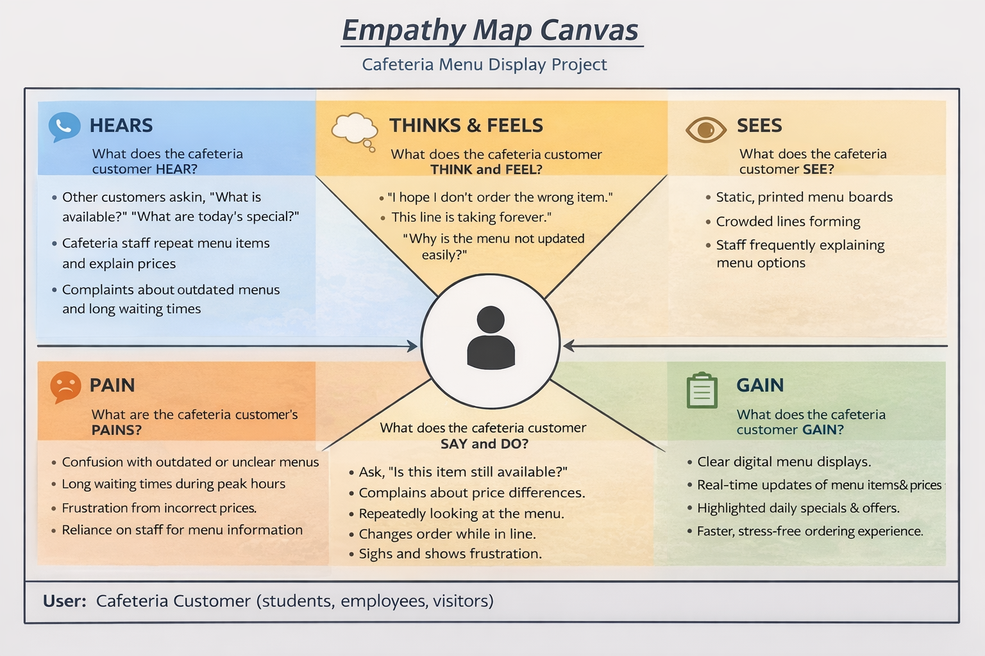

Reference: https://www.mural.co/templates/empathy-map-canvas

Example: Food Ordering & Delivery Application
